**Digital Clinic sessions’ report :**

**Session 1 :**

The current digital landscape is huge and it has especially grown on the

mobile side of things. 4.20 billion social media users with 98.8% being on mobile.

It changes the ways we have to engage with our customers, we have to balance their needs

with business needs. We also have to take into account Usability (how easy it is) and UX

(The customer journey). During this session I’ve also learned how to make a customer persona

and mapping their customer journey in order to better understand our targets.

Overall, this session was very interesting because it strikes down a subject that is very relevant in the current job market for marketing enthusiasts.

Learning how to make a customer persona and going further into trying to visualize their customer journey was definitely something that will come up when the need for targeting comes up in a regular but especially a digital job in marketing.

Creating the persona was the most entertaining part of the session for me because it forces you to think of who your customer may be and what pushes them to be interested in the business. And that goes as far as imagining even the tiniest details from their demographics but also their motivations, the frustrations they may encounter when dealing with the product/service and their overall goals.

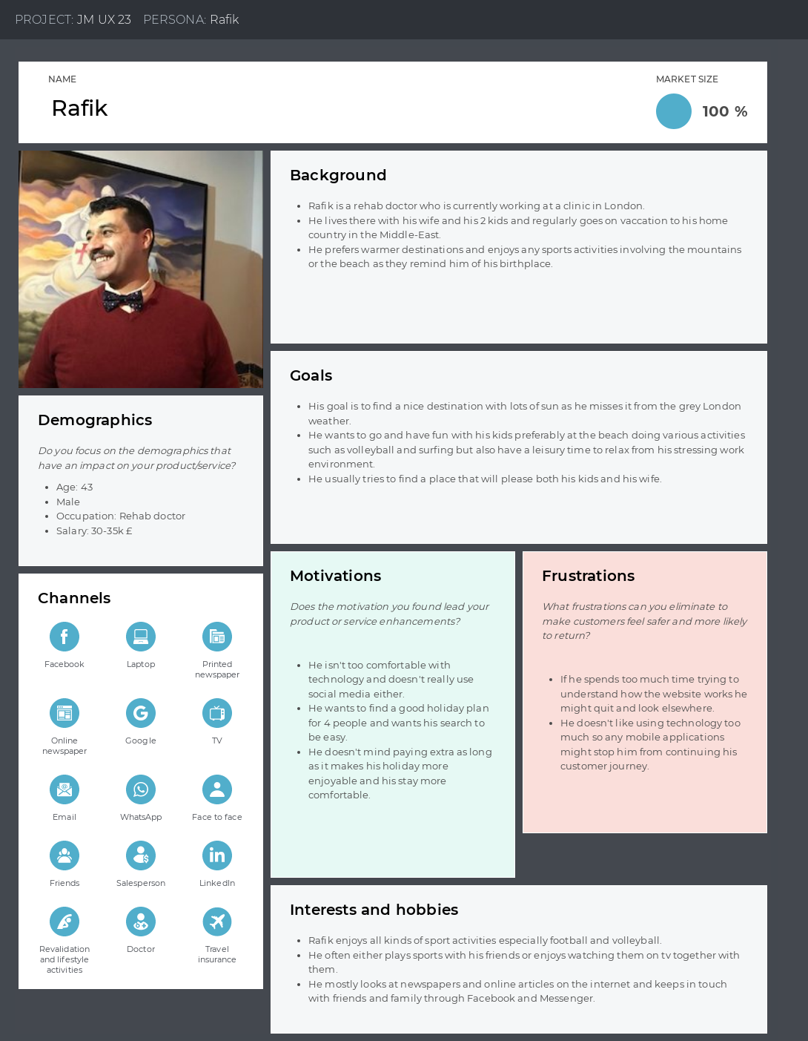**Example of a customer persona for SkiandSurf**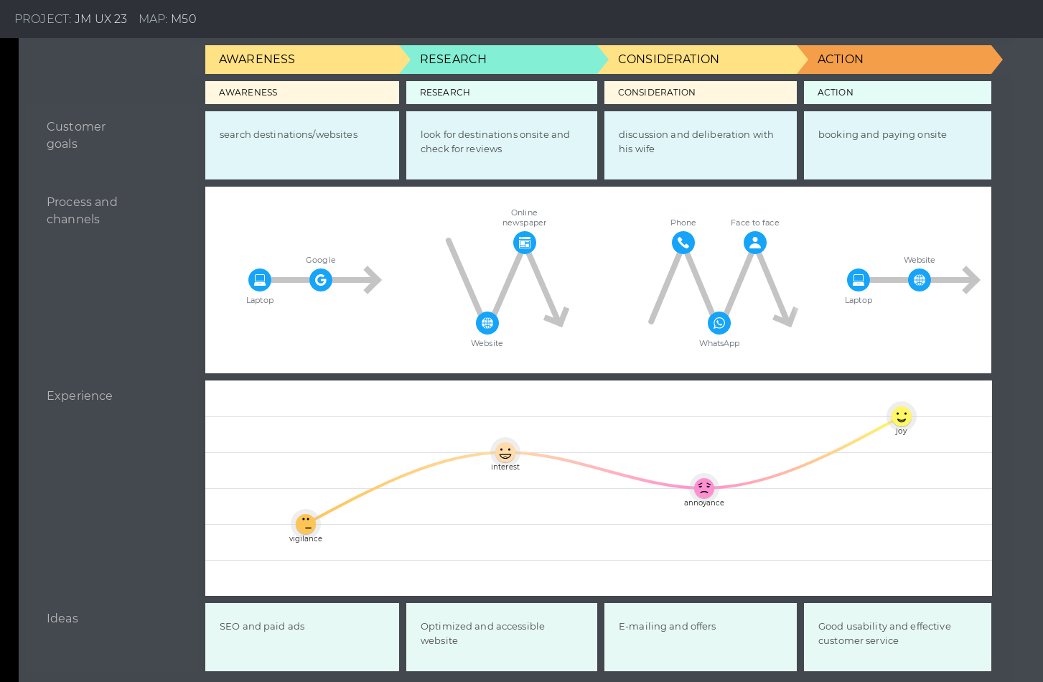

**Example of a customer journey map**

**Session 2:**

In this session, google analytics was the focus. I learned how to make ads, link it to a website, and even how to get reports from it. Through web analytics we can get quite a few of important tidbits of info.

Bounce rate, CTR, conversion and even direct or indirect referrals are some examples of that. Either way from there we can establish specific reports about our website's audience, content, traffic, ecommerce performance and more.

Here the main point was playing around with Google analytics and trying to generate information reports in order to get specific info about the previously mentioned variables.

This is quite important as getting accustomed to this will be a good start in anyone trying to gather information about a business and this is twice as important when working in marketing.

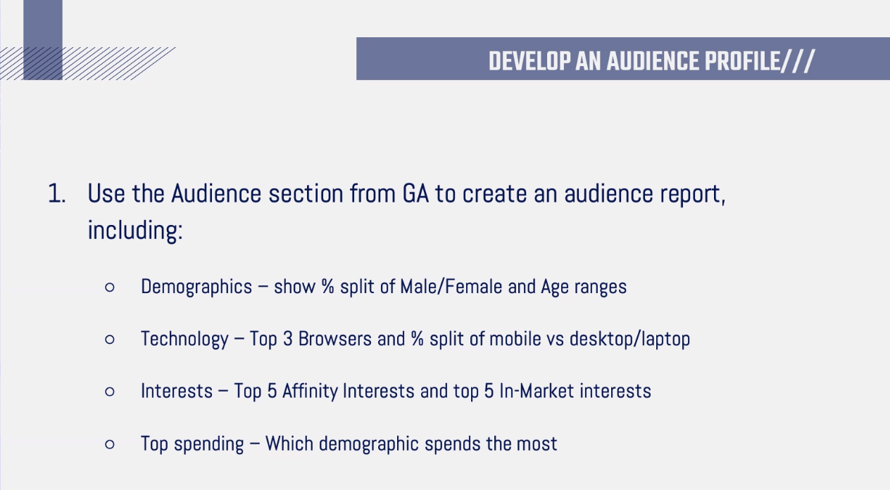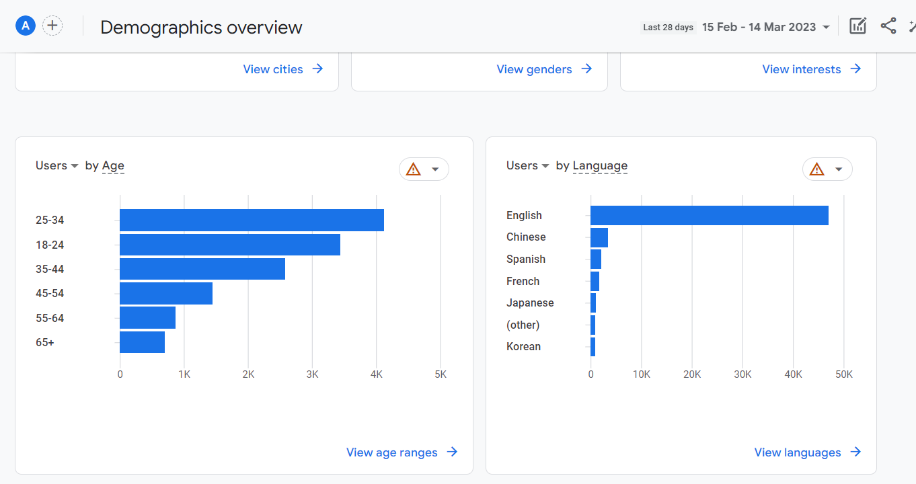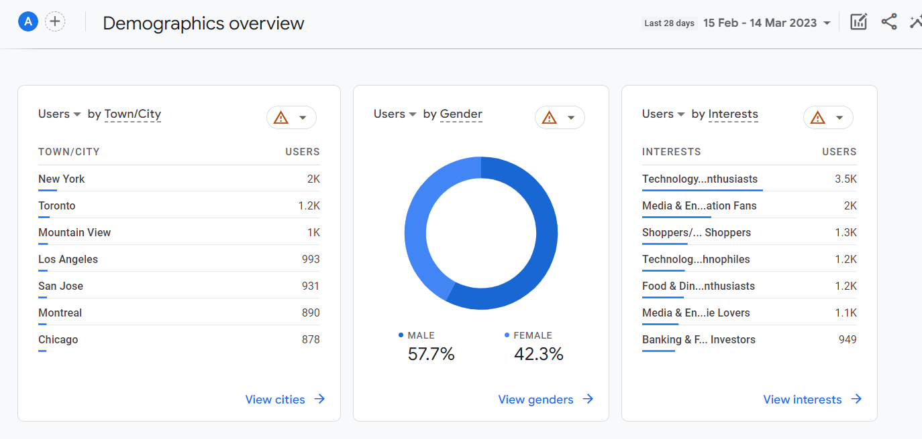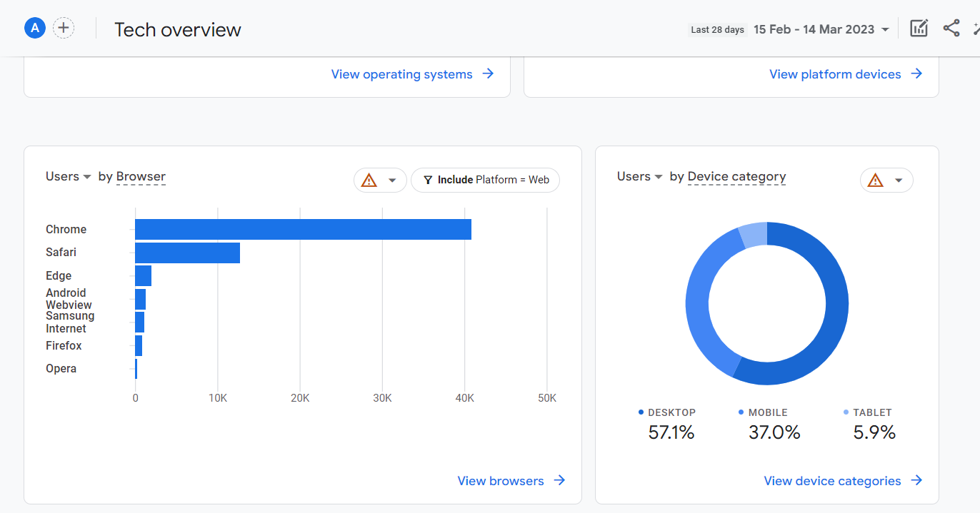

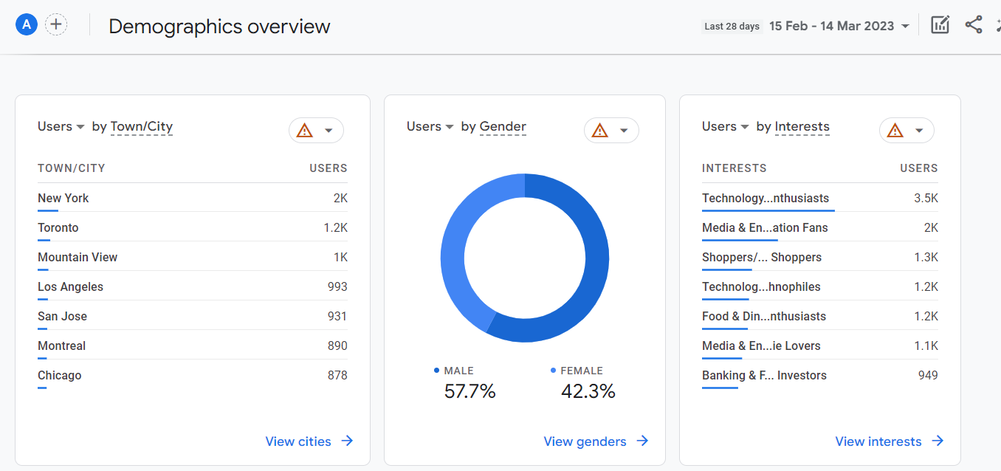

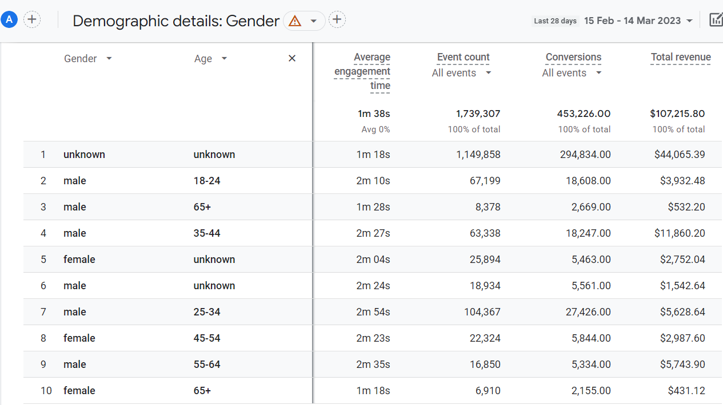

**Some examples of reports extracted from Google Analytics**

**Session 3 :**

Social media marketing was the main subject here. A few more details were added to the

previously done customer persona focusing on social media platforms and digital channels

used.

It is also very important to understand or predict which types of content our customer base

would be most sensible to. There is also the fact that there are a few different media strategies

that can be used or are already used by companies. Depending on if it is paid media, earned media or

owned media, the strategy may vary. Also, different approaches may be used depending on the

actual social media platform, for example short videos might be better used on Tik Tok rather than Facebook.

Speaking of Tik Tok and Facebook, we’ve been able to look at the various possibilities that a marketing professional may make use of with the official accounts. A lot of these options such as choosing demographics for your ads and other campaigns were available and let us see how this could be applied in a real-life scenario.

This seemed like a very important part of the session to me because of how directly linked to social media management is to marketing experts in general.

However, this was a bit rough to showcase in my opinion and unless we had an easier time getting access to it this was still a bit limited. (even though I am grateful for being to see how it works “backstage”)

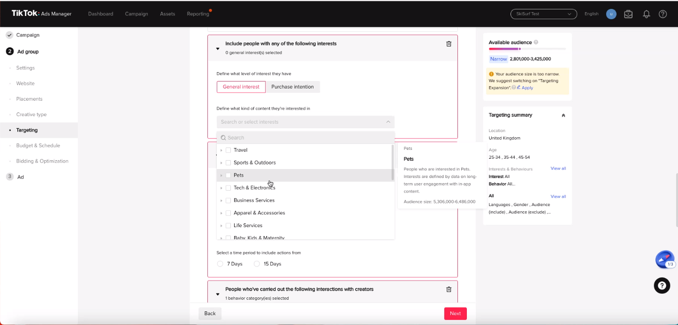

**A showcase of Tik tok Ad Manager possibilities**

**Session 4:**

Data Driven Marketing and its ramification. Strategy, SEO, Automation, ads and more.

Using customer data to generate behavioral insights lets some companies outperform peers by 85%

in sales growth and 25% in gross margin. Using HubSpot is very good at syncing

and linking all our data and allowing us to visualize and manage it more easily.

It is also a fantastic tool to use a CRM, launch marketing or emailing campaigns and even

design ads or a landing page. Using automation, it's even possible to automate the whole process

by creating workflows. (Making lists and adding contacts, sending follow-up emails, coding chatbots, etc)

Regardless of all the potential HubSpot has, it is wasted on someone who can’t make full use of it. This was by far the most draining session, but it was also the most interesting out of them all in my opinion.

The site seems like a very complete assistant to anyone who might want to manage a business and a very important one at that. From creating lists of clients and making use of the CRM to creating actual ads, this was an extremely fruitful experience.

This will be, without a doubt a very important skill to showcase to future employers as making good use of this website will definitely give an edge to any company compared to those who wouldn’t use it.



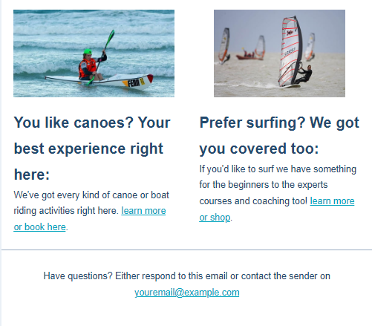

**Example of an email for SkiandSurf customers made with HubSpot**

**Job Prospects:**

Since my Bachelor’s I’ve wanted to get a job in Marketing, and following my education courses I’ve slowly but surely gathered a various skillset which is qualified to fit in this industry.

As such my current long-term goal is to work as a Marketing executive, but as it is a highly qualified job that needs a certain amount of experience, it would be quite hard to be able to get this kind of position straight out of university.

Regardless of the difficulty, starting as a Digital Marketing Assistant and gaining the experience that I need would be a good start, but keeping a close eye on the long-term goal is most important in this case. Possibly starting as Digital Marketing Specialist is also a possibility.

Overall, the skills that I need will need to be polished and once I get into the industry, new skills will be available for learning and adapting my current skillset to the situation will be a crucial part of my career path.

Learning new skills such as learning some design and editing skills or even data analysis skills are also a few possibilities that I am considering, as the current job market seems to be interested in people who can showcase a varied number of skills.

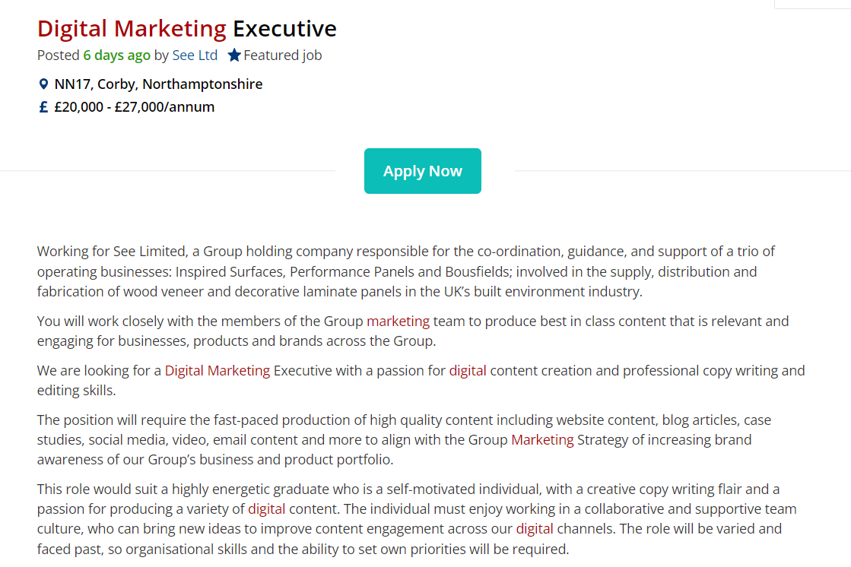

**Example of the type of job i am interested in**